Auto Ticket Classification using Flow Designer
PHASE 6: Project Testing Phase

1. Testing Objective
Testing validates the end-to-end automation, confirms data accuracy and checks that the system meets the functional requirements.
2. Data Validation Checks
- Mandatory fields are captured correctly.
- Auto-number is generated without duplication.
- Category and Subcategory values are stored accurately.
- Reference fields resolve correctly to users and groups.
3. Test Scenario 1 – Wi-Fi Issue
- Enter a Caller Name.
- Enter Short Description: WiFi not working in library.
- Save the form and reload it.
- Verify Category is Network.
- Verify Subcategory is WiFi.
- Verify that an email is sent to the caller.

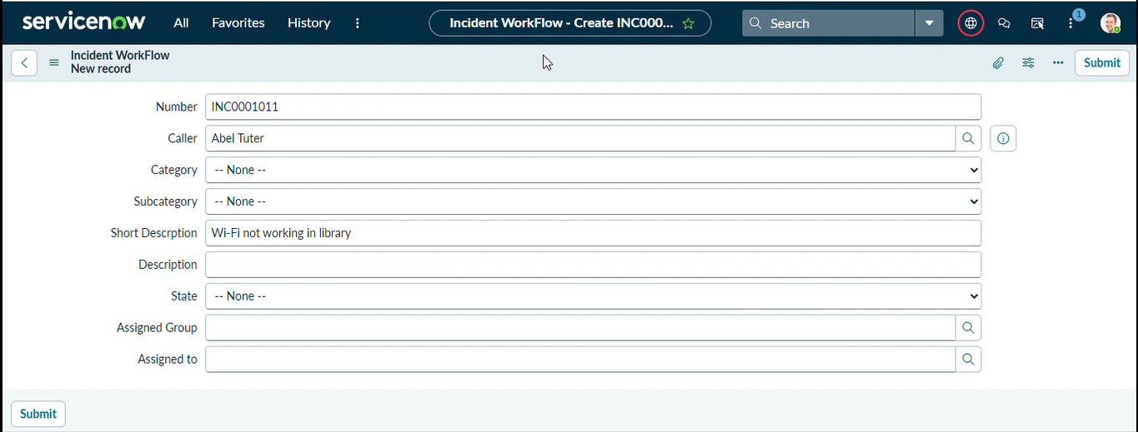
4. Test Scenario 2 – Projector Issue
- Enter a Caller Name.
- Enter Short Description: Projector not turning on.
- Save the form and reload it.
- Verify Category is Hardware.
- Verify Subcategory is Projector.
- Verify that an email is sent to the caller.

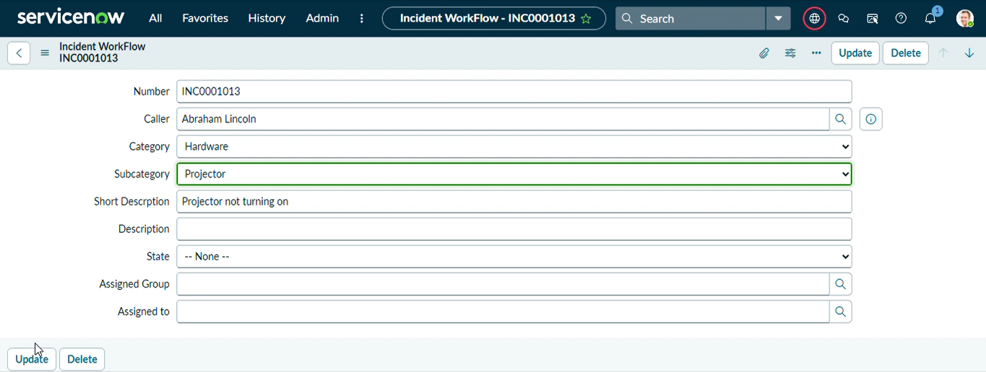

5. Email Notification Verification
- Open All menus and search Emails.
- Under System Logs, select Emails.
- Search using the configured subject.
- Open the email record and preview the mail from the related links.

